ECA10
MICROPROCESSORS AND
MICROCONTROLLERS

Name: Yarra Pawan
Reg No: 192424294

MASTER RECORD
With
Test cases
1
INDEX
S. No | Name of the Experiment | Page No.
8086 Microprocessor
6. | 16-bit Addition using indirect addressing with carry in 8086 Microprocessor
7. | 16-bit Subtraction with borrow in 8086 Microprocessor
8. | 16-bit Multiplication operation using 8086 Microprocessor
9. | 16-bit Division operation using 8086 Microprocessor
10. | Logical operations in 8086 Microprocessor  [a] Masking of bits using AND operation.  [b] Setting of bits using OR operation.  [c] Exclusive-OR operation using 8086 Microprocessor
11. | 1’s and 2's complement of a 16-bit number using 8086 Microprocessor
12. | String Operation using 8086 Microprocessors: Move a block of data from source to destination
13. | Sum of N Numbers in a word array using 8086 Microprocessor
14. | Factorial of number using 8086 microprocessor
15. | Square of number using 8086 microprocessor

22
6. ADDITION OF 16 BIT NUMBERS WITH CARRY
AIM:
To write and execute an assembly language program to add two 16-bit unsigned numbers with carry in 8086 kit.
APPARATUS:
1. 8086 microprocessor kit 1
2. Power card 1
3. Keyboard 1
ALGORITHM:
1. Load the First Data in AX-register.
2. Load the First Data in BX-register.
2. Add the two data and get the sum in AX-register.
3. If C=0 then skip next step.
4. Increment CX Reg for carry
5. Store the sum in memory locations.
6. Store the Carry in memory location.
7. Stop the program.
PROGRAMM
ADDRESSLABEL |  | MNEMONICS | OPCODE | COMMENT
1100 |  | MOV CX,0000H |  | Initialize counter CX
1104 |  | MOV AX,[1200] |  | Get the first data in AX register.
1108 |  | MOV BX,[1202] |  | Get the second data in BX register.
110C |  | ADD AX,BX |  | Add the contents of both the register AX & BX
110E |  | JNC L1 |  | Check for carry
1110 |  | INC CX |  | If carry exists, increment the CX
1111 | LI | MOV [1206],CX |  | Store the carry
1113 |  | MOV [1204],AX |  | Store the sum
1117 |  | HLT |  | Stop the program

OUTPUT FOR ADDITION:

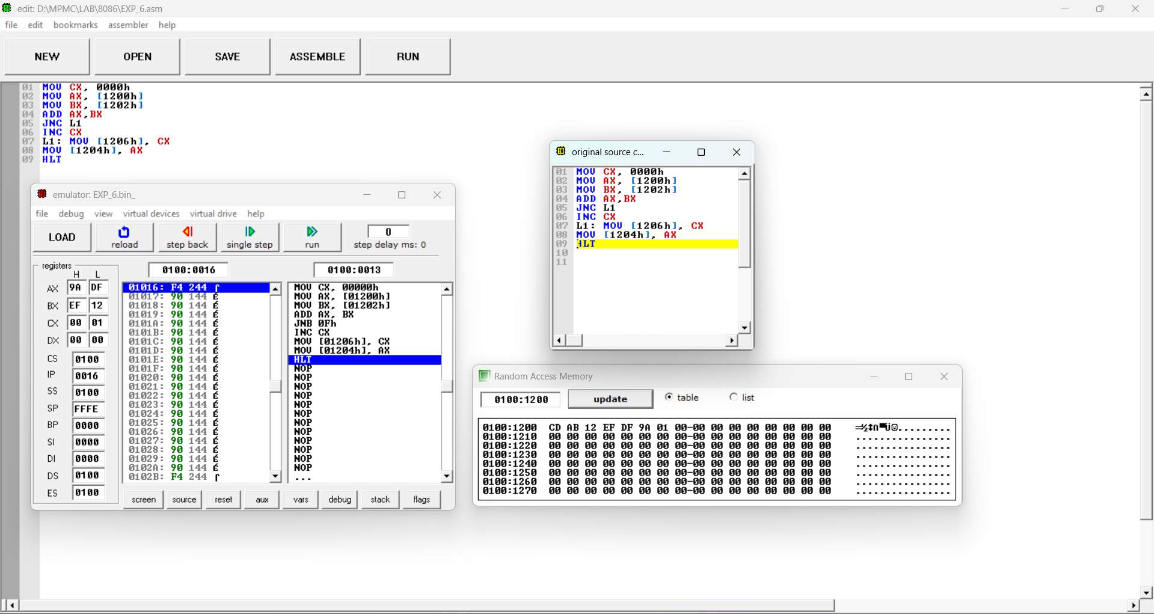
INPUT |  | OUTPUT
Address | Data | Address | Data
1200 | ABCD | 1204 | 9ADF
1202 | EF12 | 1206 | 0001

RESULT
Thus, an assembly language program for addition with carry of given 16-bit numbers was written, executed and Verified the Result successfully using 8086 kit
.
23
7.SUBTRACTION OF 16 BIT NUMBERS WITH BORROW
AIM
To write and execute an assembly language program to subtract two 16-bit unsigned numbers with borrow in 8086 kit.
APPARATUS:
1. 8086 microprocessor kit 1
2. Power card 1
3. Keyboard 1
ALGORITHM:
1. Load the second data from memory to the accumulator and move it to B register. 2. Load the first data from memory to the accumulator.
3. Subtract the content of B – register from accumulator
4. If Carry flag = 0 then jump to step 5 & 6
5. Increment C register to count the borrow
6. Take two’s complement of the difference
7. Store the Difference in memory.
8. Move the borrow to accumulator and store in memory.
9. Stop.
PROGRAMM
ADDRESS | LABEL | MNEMONICS | OPCODE | COMMENT
1100 |  | MOV CX,0000H |  | Initialize counter CX
1104 |  | MOV AX,[1300] |  | Get the first data in AX register
1108 |  | MOV BX,[1302] |  | Get the second data in BX register.
110C |  | SUB AX,BX |  | Subtract the contents of both the register AX & BX
110E |  | JNC SKIP |  | Check the Borrow.
1110 |  | INC CX |  | If carry exists, increment the CX
1111 |  | NEG AX |  | Take two’s complement of the difference
1113 | SKIP | MOV [1306],CX |  | Store the Borrow.
1117 |  | MOV [1304],AX |  | Store the difference.
111A |  | HLT |  | Stop the program

OUTPUT FOR SUBTRACTION:
INPUT |  | OUTPUT
Address | Data | Address | Data
1200 | ABCD | 1204 | 4345
1202 | EF12 | 1206 | 0001
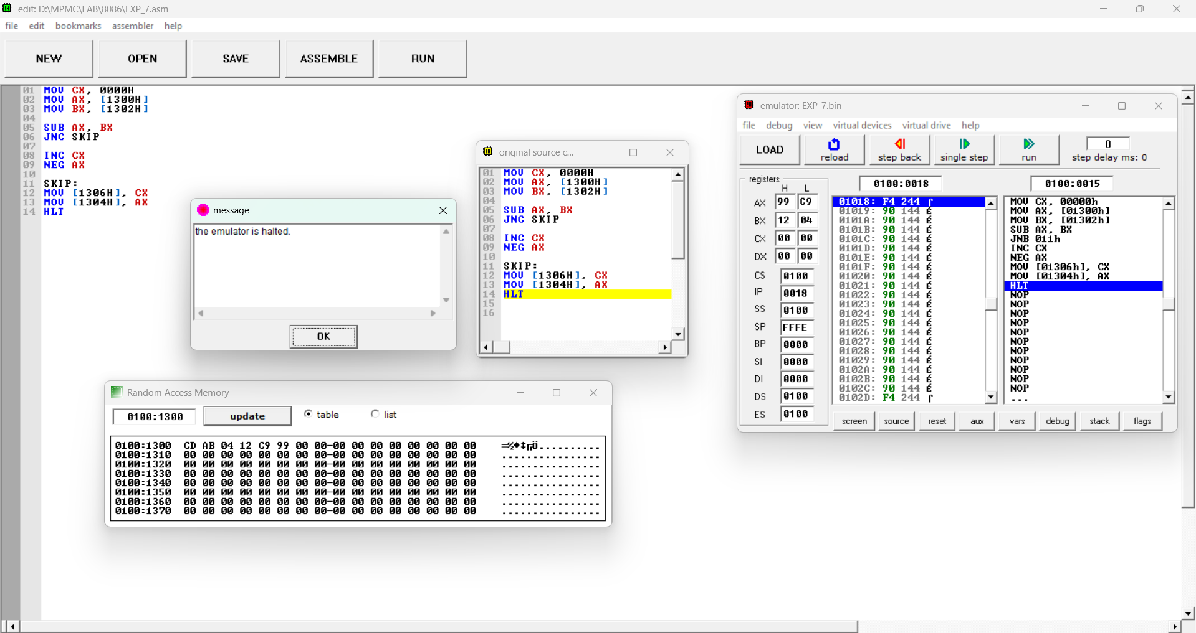

RESULT
Thus, an assembly language program for subtraction with borrow of given 16-bit numbers was written, executed and Verified the Result successfully using 8086 kit.
24
8. MULTIPLICATION OF 16 BIT NUMBERS
AIM
To write and execute an assembly language program to Multiply two 16-bit unsigned numbers in 8086 kit.
APPARATUS:
8086 microprocessor kit 1
Power card 1
Keyboard 1
ALGORITHM:
1. Load the multiplier from memory to accumulator.
2. Load the Multiplicand from memory to BX Reg .
3. Multiply AX with BX.
4. Store the Lower word in memory from AX.
5. Store the Higher word in memory from DX.
6. Stop.
PROGRAMM
ADDRESS | LABEL | MNEMONIC |  | OPCODE COMMENTS
1100 |  | MOV AX, [1200] |  | Load AX-register with 1st data
1104 |  | MOV BX,[1202] |  | Load BX-register with 2nd data
1105 |  | MUL BX |  | Multiply the contents of AX with BX-register
1106 |  | MOV [1204],AX |  | Store the Lower word
1109 |  | MOV [1206],DX |  | Store the Higher word
110D |  | HLT |  | Stop the program

OUTPUT:
INPUT |  | OUTPUT
Address | Data | Address | Data
1200 | ABCD | 1204 | 776A
1202 | EF12 | 1206 | A070
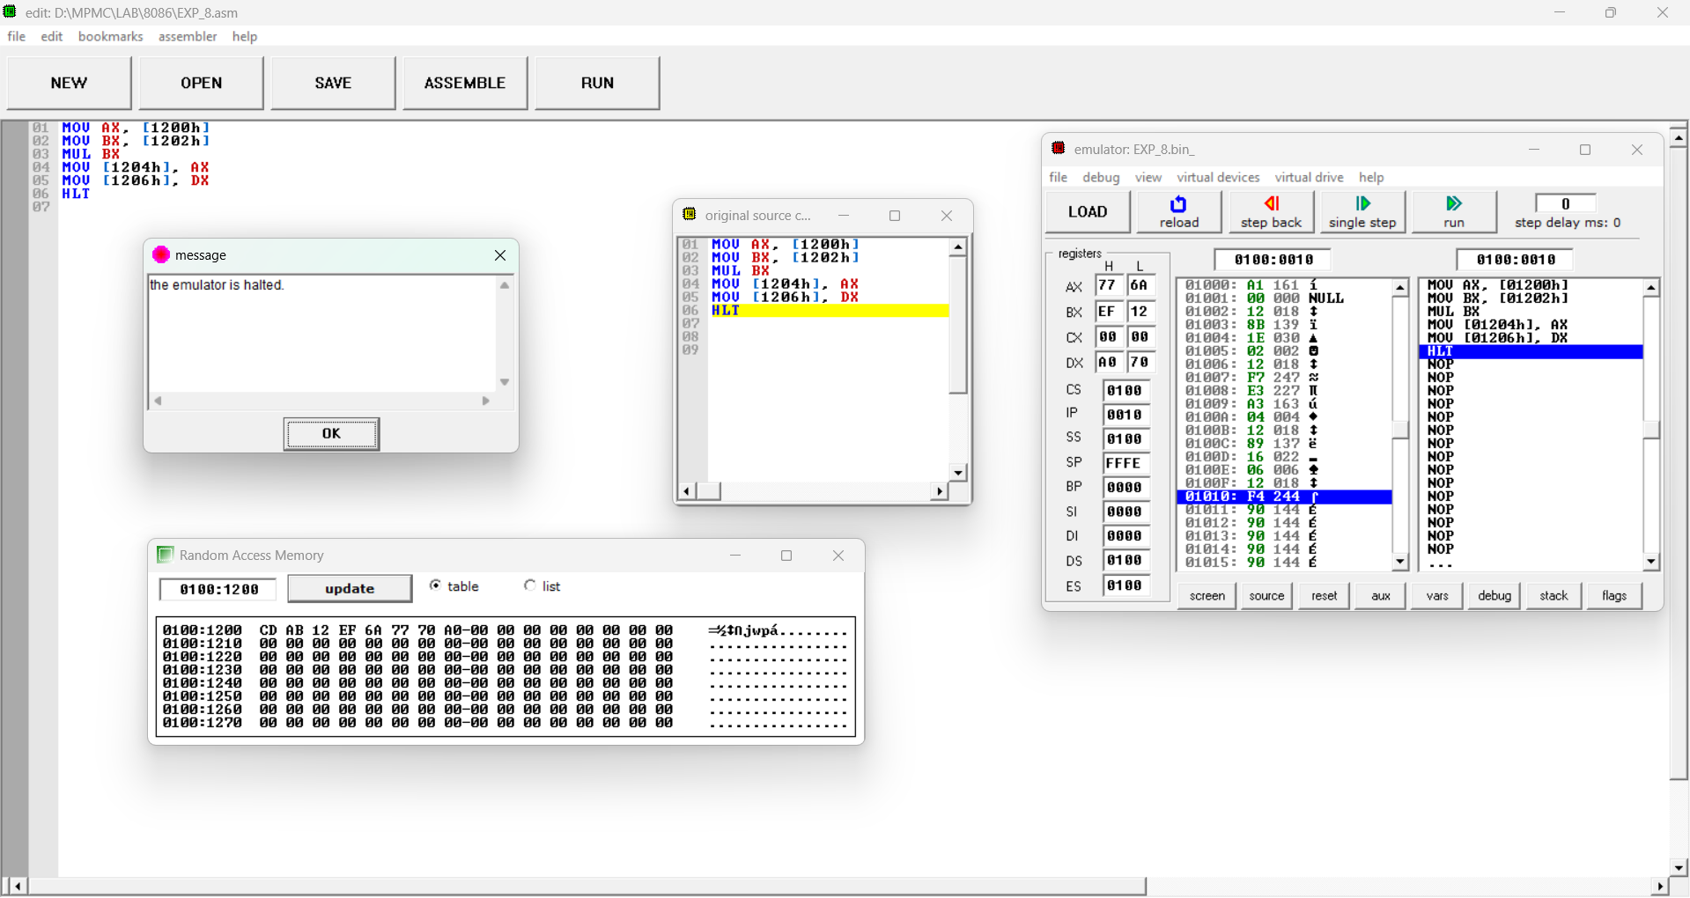

RESULT
Thus, an assembly language program for multiplication of given 16-bit numbers was written, executed and Verified the Result successfully using 8086 kit.
25
9. DIVISION OF 16 BIT NUMBERS
AIM
To write and execute an assembly language program to Divide two 16-bit unsigned numbers in an 8086 kit.
APPARATUS:
8086 microprocessor kit 1
Power card 1
Keyboard 1
ALGORITHM:
1. Load the Divisor from memory to accumulator.
2. Load the Divisor from memory to BX Reg .
3. Divide DXAX by BX.
4. Store the Quotient in memory from AX.
5. Store the Reminder in memory from DX.
6. Stop.
PROGRAMM
ADDRESS | LABEL | MNEMONICS | OPCODE | COMMENTS
1100 |  | MOV DX,0000 |  | Initialize DX-register with Lsb of Dividend
1104 |  | MOV AX, [1200] |  | Load AX-register with Dividend
1108 |  | MOV BX, [1202] |  | Load BX-register with Divisor
1109 |  | DIV CX |  | Divide AX by BX-register
110A |  | MOV [1204], AX |  | Store the Quotient
110D |  | MOV [1206], DX |  | Store the Remainder
1112 |  | HLT |  | Stop the program

OUTPUT:
INPUT |  | OUTPUT
Address | Data | Address | Data
1200 | EF12 | 1204 | 0001
1202 | ABCD | 1206 | 4345

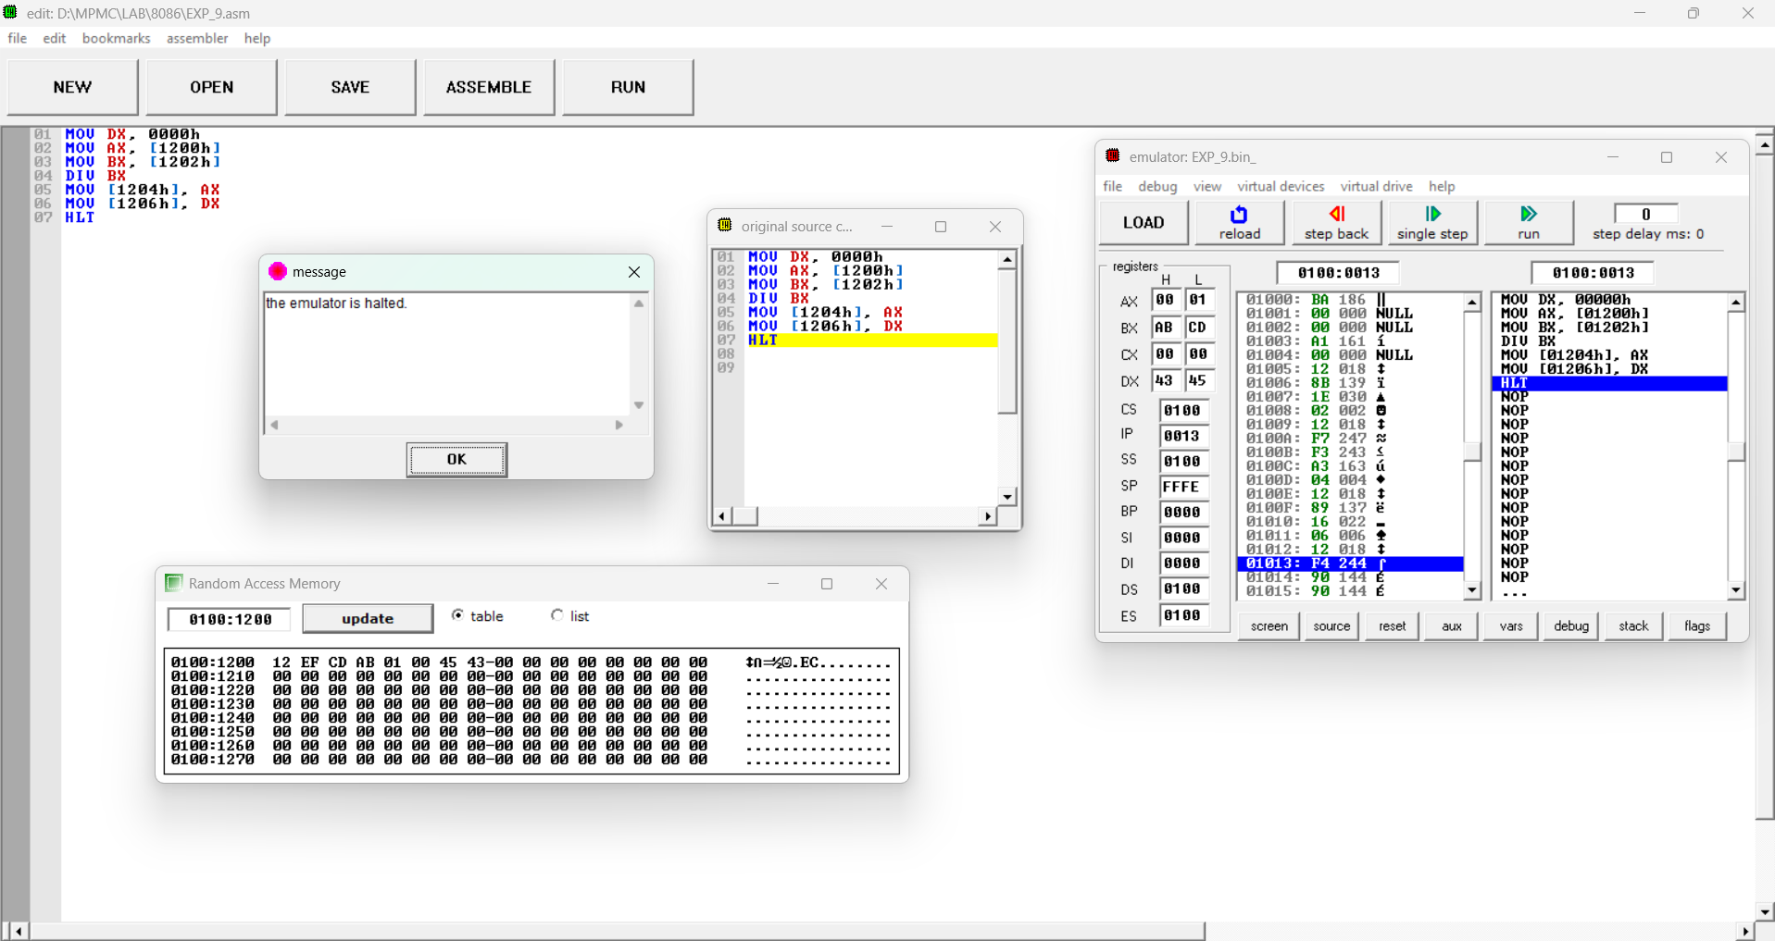
RESULT
Thus, an assembly language program for Division of given 16-bit numbers was written, executed and Verified the Result successfully using 8086 kit.
26
Test Cases: Arithmetic Operations of 8086 Microprocessor
Test Case Question 1: These test cases are for the arithmetic operations such as addition and subtraction. Each test case includes the initial values of registers and memory locations, the operation to be performed, and the expected results.
(iii) Initial Register Values:
AX Register = 1234H
BX Register = 5678H
Operation: What will be the value in the AX and the carry flag (CY) after executing the instruction ADD BX?
(iv) Initial Register Values:
AX Register = 6A19H
BX Register = 5C15H
Operation: What will be the value in the AX and the carry flag (CY) after executing the instruction SUB BX?
Test Case Question 2: These test cases are for the arithmetic operations such as multiplication, and division. Each test case includes the initial values of registers and memory locations, the operation to be performed, and the expected results.
(i) Initial Register Values:
AL Register = CDH
BL Register = A2H
Operation: What will be the values in the accumulator (A) and the B Register (B) after executing the instruction MUL B?
(ii) Initial Register Values:
AX = 2C5B (Dividend)
BL = 56H (Divisor)
Operation: What will be the values in the AX and the BL Register after executing the instruction DIV B?

27
10.LOGICAL OPERATION
AIM:
To write and execute an assembly language program for performing Masking, Setting, One’s and Two’s Complement of given 16-bit numbers using 8086 Microprocessor.
APPARATUS:
8086 microprocessor kit 1
Power card 1
Keyboard 1
MASKING OF BITS
ALGORITHM:
Load the Data in AX-register.
Logically AND the content of AX with 0F0FH.
Store the result in memory location.
Stop the program
PROGRAM:
By using 8086 kit:
ADDRESS | OPCODE | LABEL | MNEMONICS | COMMENTS
1100 |  |  | MOV AX,[1200] | Load AL-register with 1st Data
1104 |  |  | AND AX, 0F0FH | AND the content of AX with 0F0FH
1108 |  |  | MOV [1202],AX | Store the Result
110C |  |  | HLT | Stop the program

OUTPUT:
INPUT |  | OUTPUT
Address | Data | Address | Data
1200H | ABCD | 1202H | 0B0D

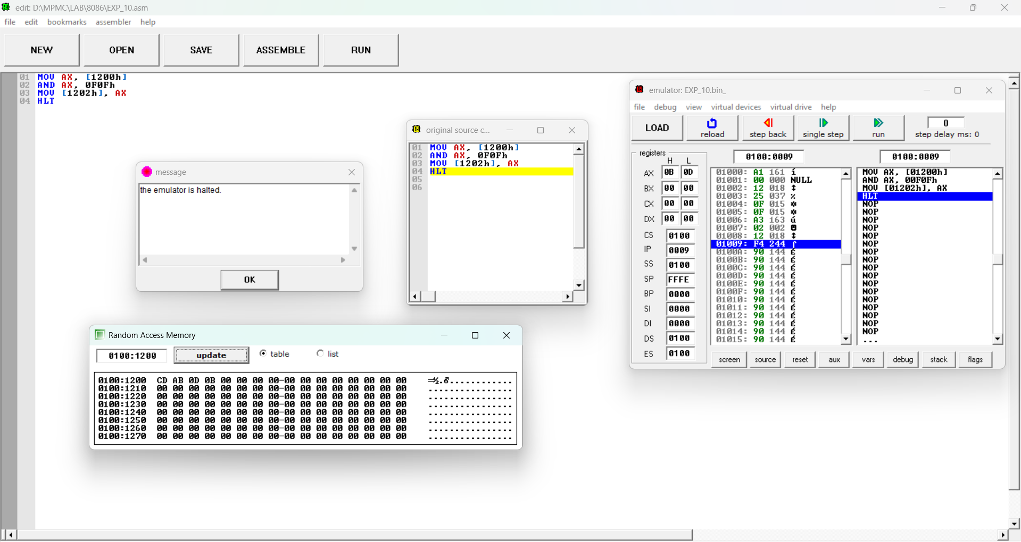
28
SETTING OF BITS
ALGORITHM:
3. Load the Data in AX-register.
4. Logically OR the content of AX with 0F0FH.
5. Store the result in memory location.
6. Stop the program
PROGRAM:
vi) By using 8086 kit:
ADDRESS | OPCODE | LABEL | MNEMONICS | COMMENTS
1100 |  |  | MOV AX,[1200] | Load AL-register with 1st Data
1104 |  |  | OR AX, 0F0FH | AND the content of AX with 0F0FH
1108 |  |  | MOV [1202],AX | Store the Result
110C | F4 |  | HLT | Stop the program

OUTPUT:
INPUT |  | OUTPUT
Address | Data | Address | Data
1200H | ABCD | 1202H | FBFD
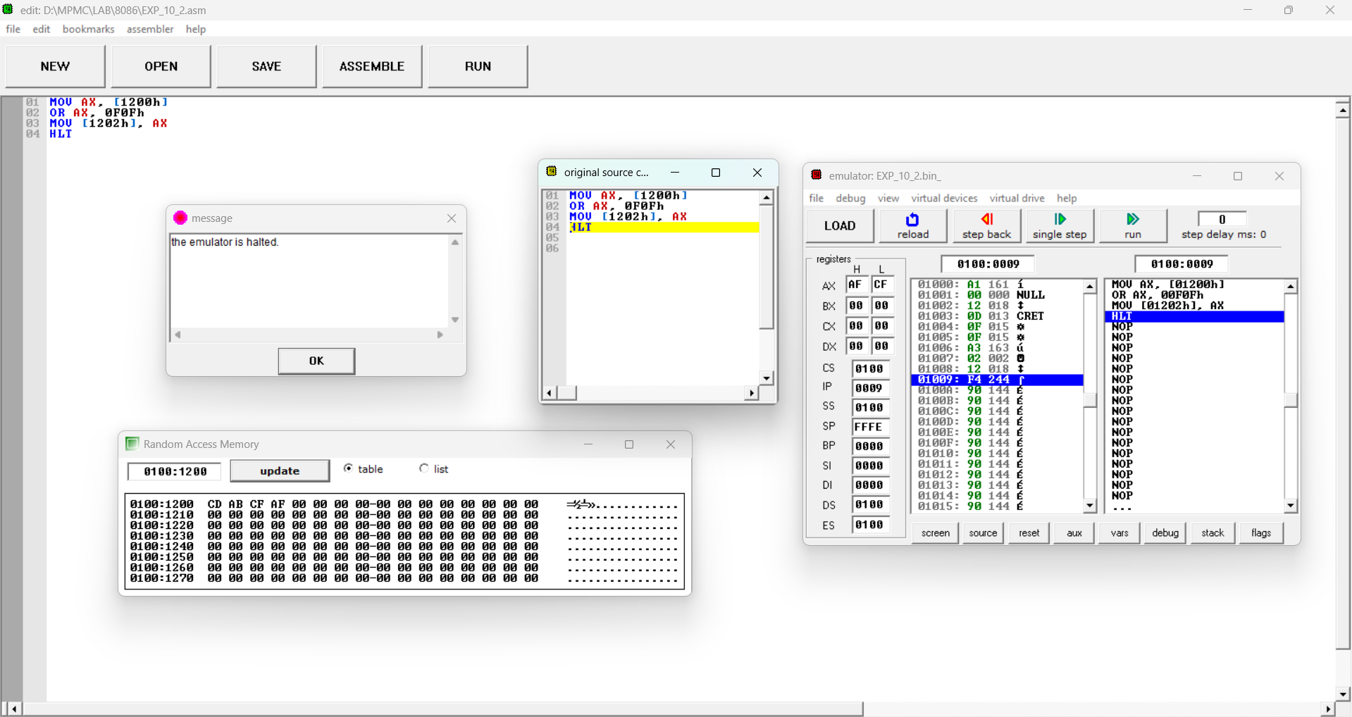

RESULT:
Thus, an assembly language program for performing logical Masking and Setting of bits were executed using 8086 kit.
29
11.ONE’S AND TWO’S COMPLEMENT
AIM:
To write and execute an assembly language program for performing One’s and Two’s Complement of given 16-bit numbers using 8086 Microprocessor.
APPARATUS:
1. 8086 microprocessor kit 1
2. Power card 1
3. Keyboard 1
MASKING OF BITS
ALGORITHM:
1. Load the Data in AX-register.
2. Logically NOT the content of AX.
3. Store the One’s complement in memory location.
4. Increment the content of AX.
5. Store the Two’s complement in memory location.
6. Stop the program
PROGRAM:
vii) By using 8086 kit:
ADDRESS | OPCODE | LABEL | MNEMONICS | COMMENTS
1100 |  |  | MOV AX,[1200] | Load AL-register with 1st Data
1104 |  |  | NOT AX | NOT the content of AX
1108 |  |  | MOV [1202],AX | Store the One’s complement in memory location.
110C |  |  | INC AX | Increment the content of AX.
110D |  |  | MOV [1204],AX | Store the Two’s complement in memory location
1110 | F4 |  | HLT | Stop the program

OUTPUT:
INPUT |  | OUTPUT
Address | Data | Address | Data
1200H | 12AB | 1202H | ED54
 |  | 1204H | ED55

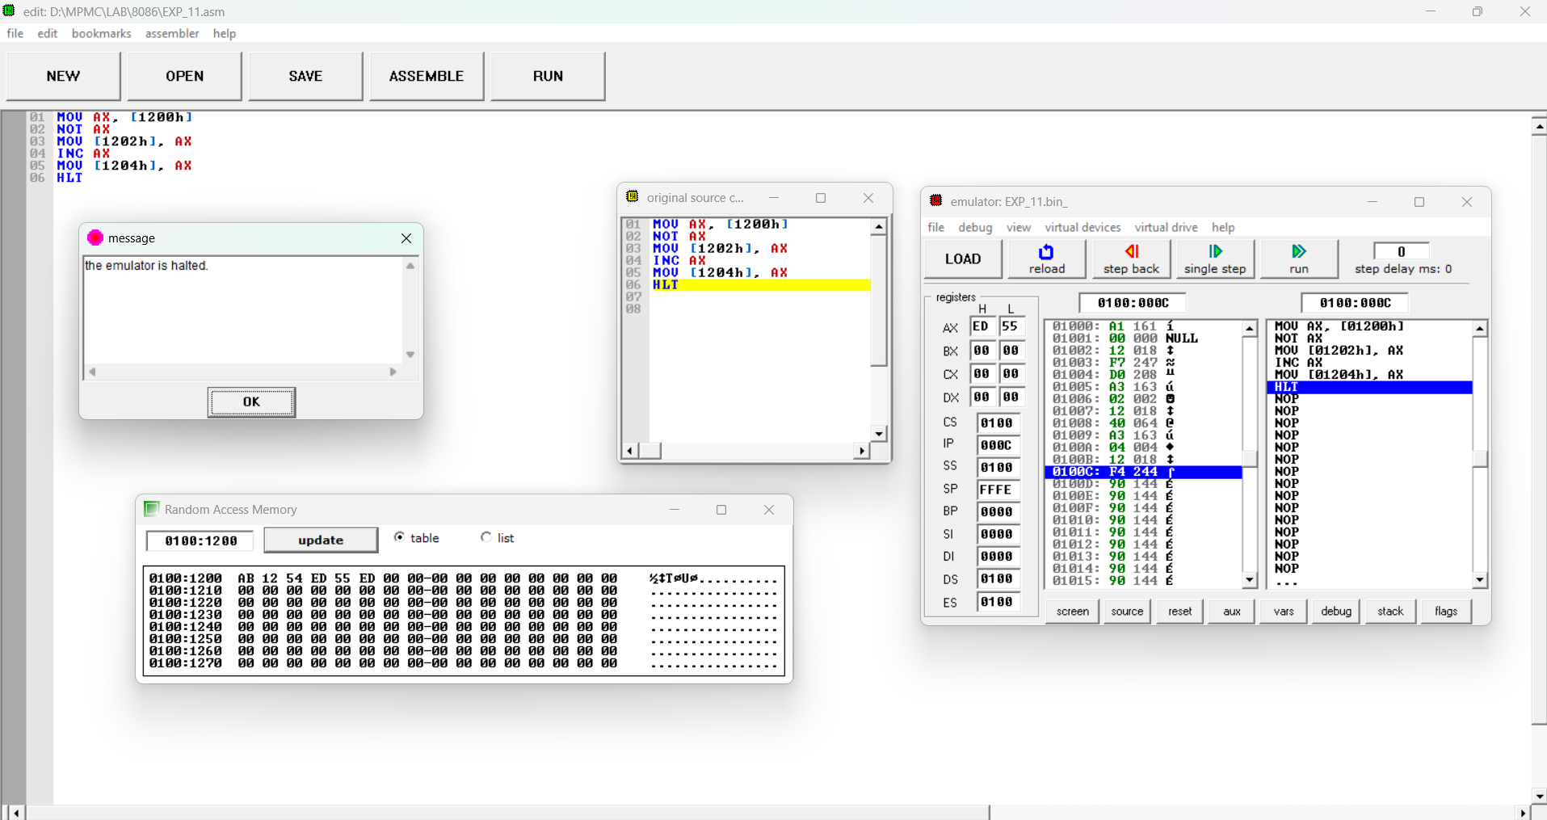
RESULT:
Thus, an assembly language program for performing One’s and Two’s Complement of bits were executed using 8086 kit.
30
Test Cases: Logical Operations of 8086 Microprocessor
Test case question 1: Load AX with 0x3A5B and apply AND with 0x0FFF.What happens when the upper nibble is masked out using AND 0x0FFF on 0x3A5B? Test case question 2: Load AX with 3F0Fh and apply AND with 0008h.What is the result after masking a random value like 0x78AB with AND 0xF0F0? Test case question 3: Load AX with a value like 0x1234, perform a series of arithmetic operations that affect flags, then apply AND to isolate the carry or zero flag.How does the AND operation interact with flag settings after arithmetic operations? Test case question 4:Load a register (e.g., AX) with 0x1234 and apply the OR operation with 0x000F.What is the result in AX after setting the lower nibble using OR 0x000F on 0x1234?
Test case question 5: Load AX with 3F0Fh and apply XOR with 0008h.How does XORing with 0008h modify the value 3F0Fh?
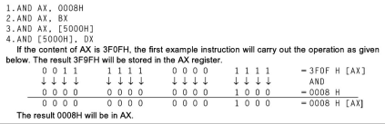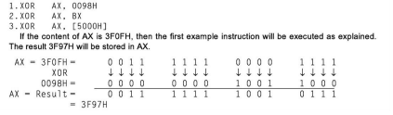

31
12.MOVE A DATA BLOCK WITHOUT OVERLAP
AIM:
To write and execute an assembly language program for transferring data from one block to another block without overlapping using 8086 kit and MASM.
APPARATUS:
1. 8086 microprocessor kit 1
2. Power card 1
3. Keyboard 1
ALGORITHM:
1. Initialize counter.
2. Initialize source block pointer.
3. Initialize destination block pointer.
4. Get the byte from the source block.
5. Store the byte in the destination block.
6. Increment source, destination pointers and decrement counter.
7. Repeat steps 4, 5 and 6 until the counter equal to zero.
8. Stop.
PROGRAM:
i) By using 8086 kit:
ADDRESS | OPCODE | LABEL | MNEMONICS | COMMENTS
1100 | C7 C6 0012 |  | MOV SI, 1150H | Initialize the source address.
1104 | C7 C7 0013 |  | MOV DI,1250H | Initialize the destination  address.
1108 | C7 C1 0600 |  | MOV CX,0006 H | Initialize count value to the count register.
110C | FC | REPEAT: CLD |  | Clear the direction flag.
110D | A4 |  | MOVSB | Move the string byte.
110E | E2,F3 |  | LOOP REPEAT | Unconditional loop to address specified by the label REPEAT.
1111 | F4 |  | HLT | Stop the program

OUTPUT:
INPUT |  | OUTPUT
Address | Data | Address | Data
1150. | 52. | 1250. | 52.
1151. | 53. | 1251. | 53.
1152. | 54. | 1252. | 54.
1153. | 55. | 1253. | 55.
1154. | 56. | 1254. | 56.
1155. | 57. | 1255. | 57.

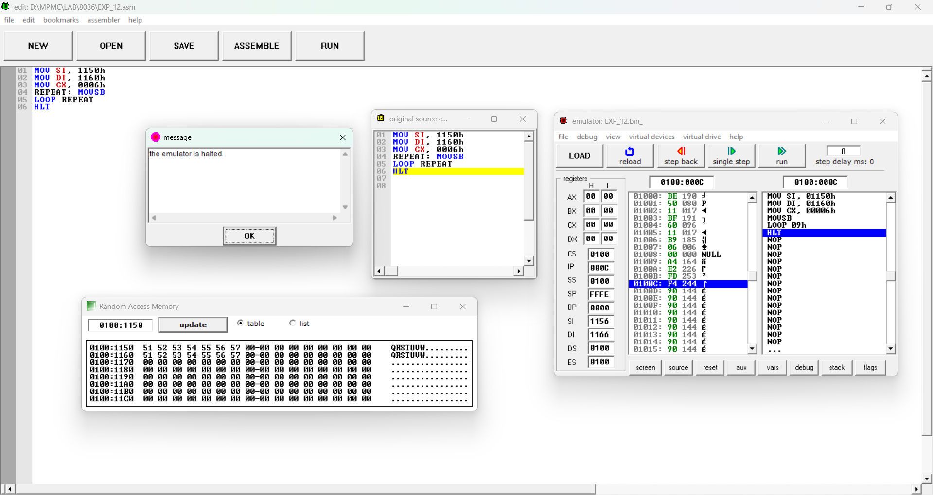
RESULT:
Thus, an assembly language program for transferring data from one block to another block without overlapping was executed using 8086 kit.
32
Test Cases : String Operations of 8086 Microprocessor
Test Case Question 1:
Test Case Scenario:
Moving a block of data from a source memory location to a destination memory location using the 8086 microprocessors. The source and destination addresses are provided. You need to ensure that the data is correctly moved from the source to the destination, and the original data in the source location is preserved.
Test Case Steps:
Load the source memory address (e.g., DS:SI) with a known source address.
Load the destination memory address (e.g., ES:DI) with a known destination address. Load the count of bytes to move (e.g., CX) with the number of bytes in the block.
Execute a string move instruction (e.g., MOVSB) to move a single byte from the source to the destination.
Repeat the move instruction for the desired number of bytes (specified by CX) until the entire block of data is moved.

Output:
Set the OFFSET S_ARRAY to 200C and OFFSET D_ARRAY to 300C.
200C: 20h
300C :20h
33
13.SUM OF N NUMBERS IN A WORD ARRAY
AIM:
To write and execute an assembly language program for adding N Numbers in a word array using 8086 kit.
APPARATUS:
1. 8086 microprocessor kit 1
2. Power card 1
3. Keyboard 1
ALGORITHM:
3. Initialize counter.
4. Initialize source block pointer.
5. Initialize destination block pointer.
6. Get the byte from the source block.
7. Store the byte in the destination block.
8. Increment source, destination pointers and decrement counter.
9. Repeat steps 4, 5 and 6 until the counter is equal to zero.
10. Stop.
PROGRAM:
ADDRESS | LABEL | MNEMONICS | OPCODE | COMMENTS
1100 |  | MOV DX,00H |  | Move 00H to DX register
1102 |  | MOV SI,1250H |  | Move Source Index to 1250H
1105 |  | MOV CX,03H |  | Move 03H to CX register
1107 |  | MOV AX, [SI] |  | Move Source Index value to Ax register
110A | A1: | INC SI |  | Increment The Source Index by one
110B |  | INC SI |  | Increment The Source Index by one
110C |  | ADD AX, [SI] |  | Add Data in SI with Data in AX register
110D |  | JNC NEXT |  | Jump No carry to Label NEXT
110E |  | INC DX |  | Increment DX register
110F | NEXT: | LOOP A1
1110 |  | INC SI |  | Increment SI
1111 |  | INC SI |  | Increment SI
1112 |  | MOV [1300H], AX |  | Move AX register data to 1300H
1116 |  | MOV [1302H], DX |  | Move DX register data to 1302
1119 |  | HLT

34
OUTPUT:
INPUT |  | OUTPUT
Address | Data | Address | Data
1250 | ABCD | 1300 | 0B64
1252 | EF98 | 1302 | 0003
1254 | DCBA
1256 | 9345

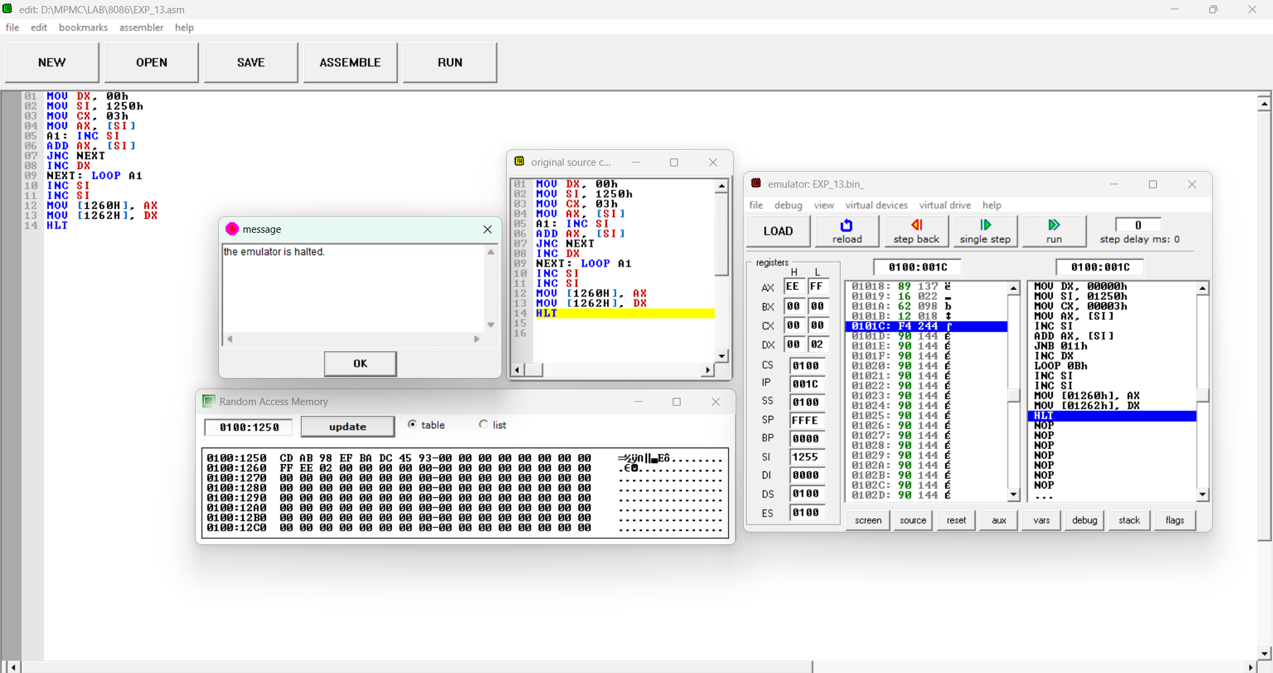
RESULT:
Thus, an assembly language program for transferring data from one block to another block without overlapping was executed using 8086 kit.
35
Test Cases: Array Operations of 8086 Microprocessor
Test Case 1: Basic Functionality
● Input:
○ Array: [1000h, 2000h, 3000h]
○ N = 3 (length of the array)
● Expected Output:
○ Sum = 6000h (stored in DX)
Test Case 2: Mixed Values
● Input:
○ Array: [FFFFh, 0001h, 0001h]
○ N = 3
● Expected Output:
○ Sum = 0001h (since FFFFh + 1h = 0000h, and adding 1h gives 0001h)
summing an array of N numbers in a word array using the 8086 microprocessor, you can assess various scenarios for understanding assembly language concepts.

36
14.FACTORIAL OF NUMBER USING 8086 MICROPROCESSOR
AIM:
To write and execute an assembly language program to find the factorial of a number using 8086.
APPARATUS:
• 8086 Microprocessor kit 1
• Power card 1
• Keyboard 1
ALGORITHM:
1. Input the Number whose factorial is to be find and Store that Number in CX Register (Condition for LOOP Instruction)
2. Insert 0001 in AX(Condition for MUL Instruction) and 0000 in DX 3. Multiply CX with AX until CX become Zero(0) using LOOP Instruction 4. Copy the content of AX to memory location 0600
5. Copy the content of DX to memory location 0601
6. Stop Execution
PROGRAM:
ADDRESS | OPCODE | LABEL | PROGRAM | COMMENTS
4100 |  |  | MOV CX, [4500] CX <-
4104 |  |  | MOV AX, 0001 | AX <- 0001
4107 |  |  | MOV DX, 0000 | DX <- 0000
410A |  | LOOP | MUL CX | DX:AX <- AX * CX
410C |  |  | LOOP 410A | Go To [040A] till CX->00
4110 |  |  | MOV [4600], AX [4600]<-AX
4114 |  |  | MOV [4601], DX [4601]<-DX
4118 |  |  | HLT | Stop the program

OUTPUT:
INPUT |  | OUTPUT
Register | Data | Address | Data
4500 | 04 | 4600 | 18
 |  | 4601 | 00
4500 | 06 | 4600 | D0
 |  | 4601 | 02

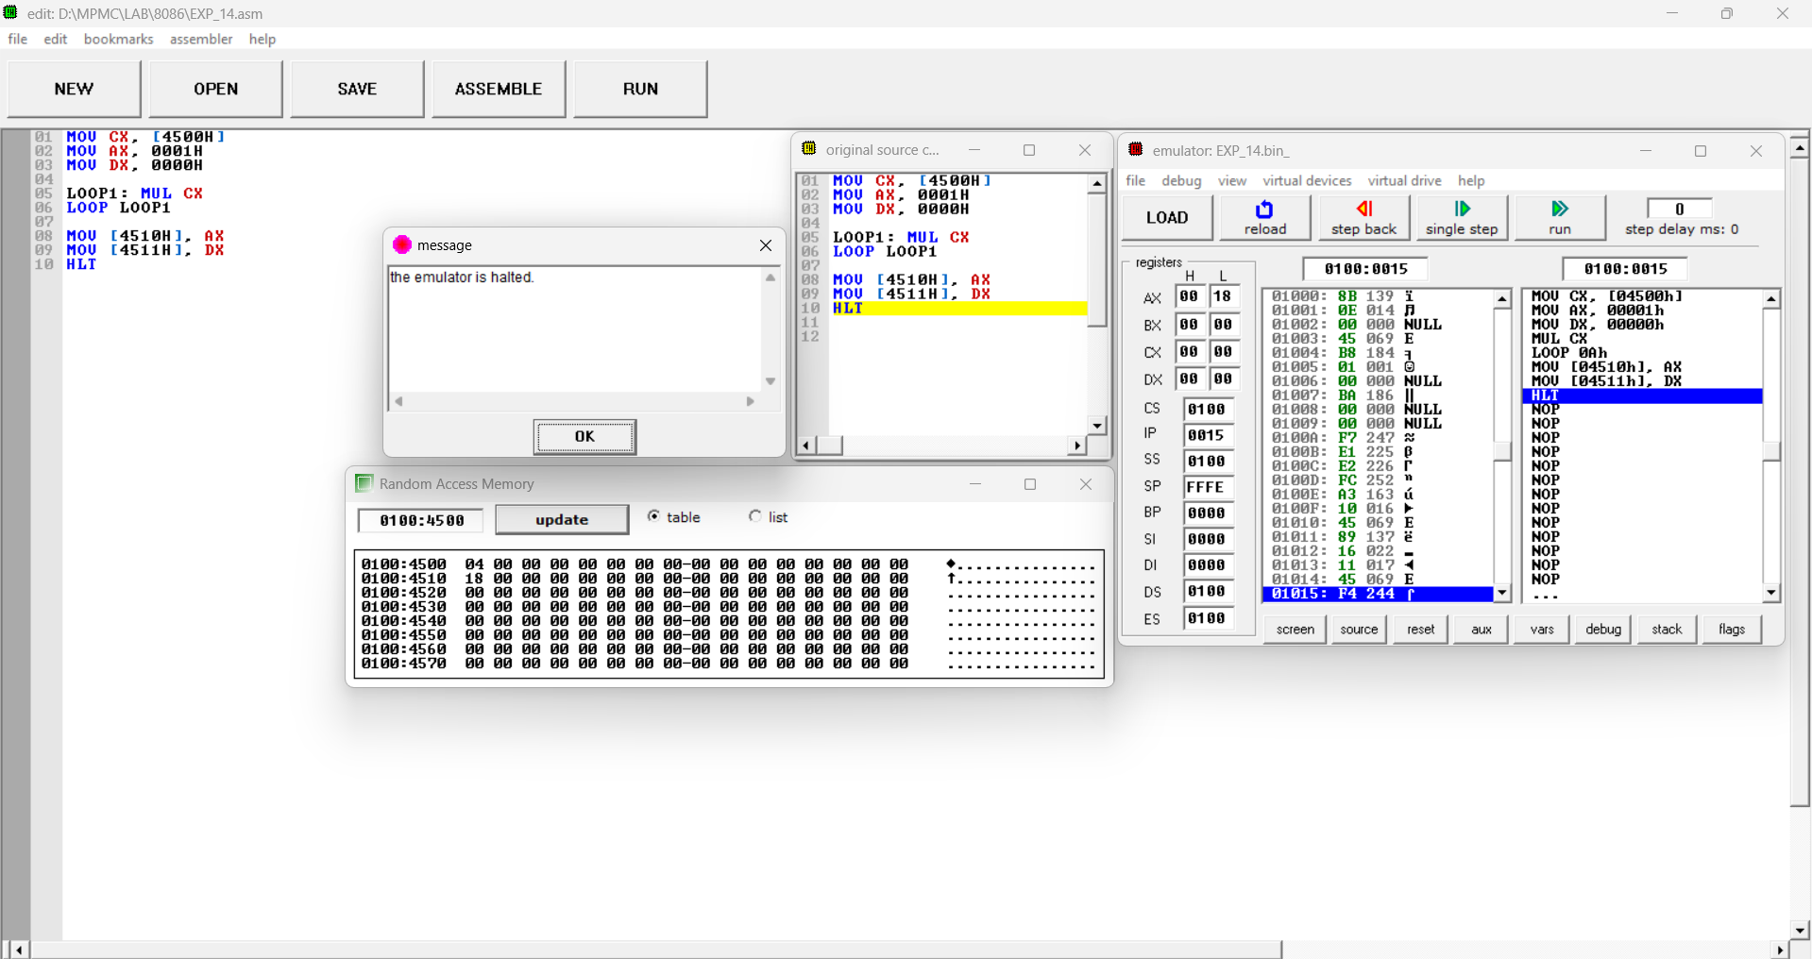
RESULT:
Thus, an assembly language program for finding the factorial of numbers using 8086 were performed and its outputs were verified.
37
15.SQUARE OF NUMBER USING 8086 MICROPROCESSOR
AIM:
To write and execute an assembly language program to find the square of a number using 8086.
APPARATUS:
• 8086 Microprocessor kit 1
• Power card 1
• Keyboard 1
ALGORITHM:
• Store 500 to SI and Load data from offset 500 to register CL and set register CH to 00 (for count).
• Increase the value of SI by 1.
• Load first number(value) from next offset (i.e 501) to register AL.
• Multiply the value in register AL by itself.
• Store the result (value of register AL ) to memory offset SI.
• Increase the value of SI by 1.
• Loop above 2 till register CX gets 0.

PROGRAM:
ADDRESS OPCODE |  | LABEL | PROGRAM | COMMENTS
4100 |  |  | MOV SI, 4500 | set the value of SI to 4500
4103 |  |  | MOV CL, [SI] | load data from offset SI to register CL
4105 |  |  | MOV CH, 00 | set value of register CH to 00
4107 |  |  | INC SI | increase value of SI by 1
4108 |  | LOOP | MOV AL, [SI] | load value from offset SI to register AL
410A |  |  | MUL AL | multiply value of register AL by AL.
410C |  |  | MOV [SI], AL | store value of register AL at offset SI.
410E |  |  | INC SI | increase the value of SI by 1.
410F |  |  | LOOP 4108 | jump to address 4108 if CX not 0 and CX=CX-1.
4111 |  |  | HLT | Stop the program
MOV SI, 4500h
MOV CL, [SI]
MOV CH,00
INC SI
LOOP: MOV AL, [SI]
MUL AL
MOV [SI], AL
INC SI
LOOP 4108
HLT

OUTPUT:
INPUT |  | OUTPUT
Register | Data | Address | Data
4500 | 04
4501 | 03 | 4601 | 09
4502 | 01 | 4600 | 01
4503 | 02 | 4601 | 04
4504 | 05 | 4602 | 25

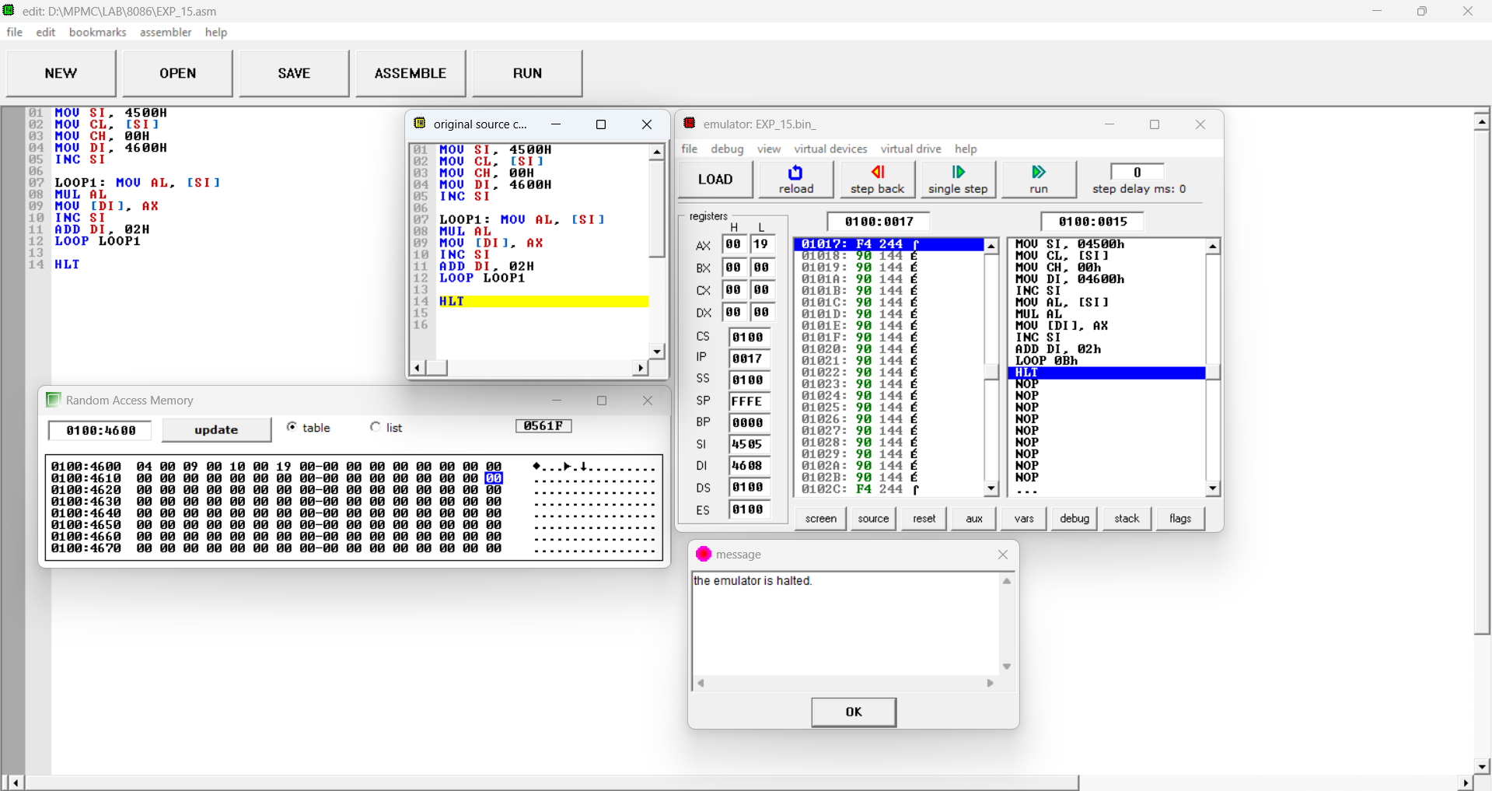
RESULT:
Thus, an assembly language program for finding the factorial of numbers using 8086 were performed and its outputs were verified.
38

